User Documentation for Thunder Bay Health Unit

1. Step 1, download XAMPP to the version of computer you have. <https://www.apachefriends.org/download.html>
2. Click next at everything and let it download. Don’t change anything.
3. Close the application if it open on it own, then search Xampp and run as administrator.
4. Check mark Apache, MySQL and FileZilla.
5. Go to MySQL and click on Config then my.ini
6. Please Change the part Highlighted to port=3307

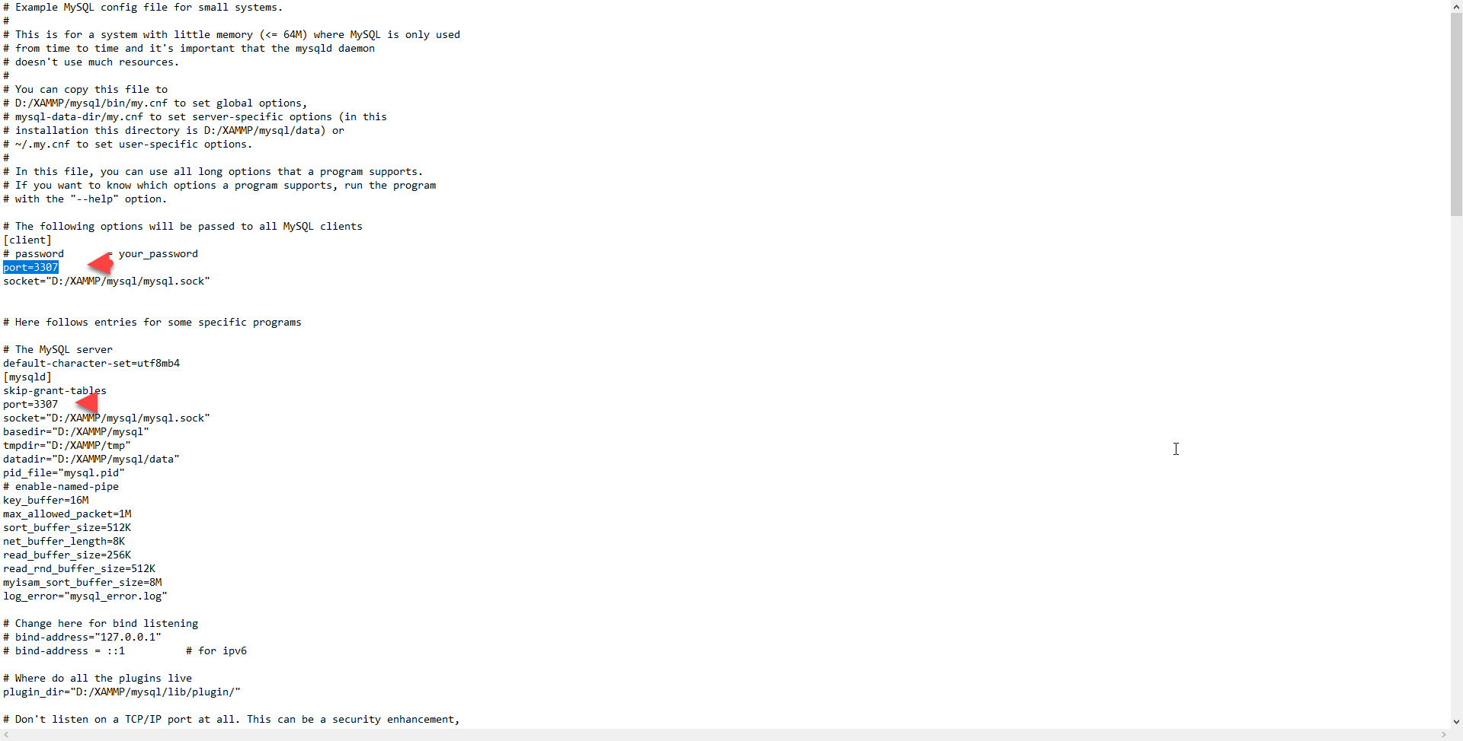

1. Open File Explorer and go to This PC/Local Disk/xampp/phpMyAdmin and find the file called config.inc.php.
2. Open it in a text file or any type of editor.
3. Go to line 27 and input this code instead

$cfg['Servers'][$i]['host'] = 'localhost:3307';

1. Unzipe the zip file in This PC/Local Disk/xampp/ htdocs and place it anywhere in that file.
2. Open the xampp panel and start Apache and MySQL
3. Now open a web browser (recommend google chrome) and put this in the browser : <http://localhost/phpmyadmin/>
4. On the left side click on new and input name (appointment_db)
5. Then on the top right click import and import the file from PC/Local Disk/xampp/ htdocs/ Health Clinic/ Database and import the file called appointment_db.sql
6. Now your able to viues the website by looking up <http://localhost/Health%20Clinic/>
7. For the login access the username is “ThunderBayHealthClinic” and password is “AdminOnly”